FACULTY PROFILE
Name : Raghu K
Designation | Assistant Professor | 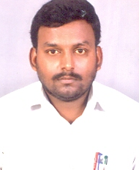  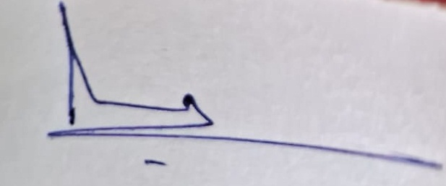
Department | English
Address (Campus) | Sri Adichunchanagiri College of Arts & Commerce, Nagamangala
(Residence) | Shanthi Nagara Pandavapura
Date of Joining into Service | 02-05-2023
Mobile | 9663005990
E-mail | raghukrishnappura@gmail.com

Educational Qualifications :
Sl. No | Degree | Name of the Institution/ University | Topic / Specialization | Year of Passing | Percentage
1 | MA, | Mysore University | English | 2008 | 61

SLET/ KSET/ UGC NET Details :
Sl. No | SLET/ KSET/ UGC NET | Year of Passing | Register Number

Teaching Experience :
Sl. No | Name and Address of the Institution | Date  (From – To) | Total Years and Months
1 | BGS PU College Srirangapattana | 2008-22 | 14

Research Experience:
Sl. No | Year | Details

Membership of Association (Non-Academic Bodies)
Sl. No | Name of the Association | Designation

BOS/BOE Details:
Sl. No | Name of the University / Autonomous College | Subject | BOS / BOE | Chairperson / Member | Year
- | - | - | - | - | -

Publications – Books :
Sl.No | Title of Book | Publisher’s Name Place and Year of Publications, ISBN No.

In Indexed/ Peer Reviewed Journals:
Sl. No | Title of the Article/Research Papers | Name of the Journal or Edited book in which published | Publisher’s Name Place and Year of Publications.  ISSN / ISBN No.
- | - | - | -

Articles / Research Papers Published :
Sl. No | Title of the Article/Research Papers | Name of the Journal or Edited book in which published | Publisher’s Name Place and Year of Publications.  ISSN / ISBN No.

Orientation Programme / Faculty Development Programme Attended:
Sl.  No | Name of the University | Date (From – To) | Place
- | - | - | -

Conference / Seminar / Workshop Attended :

Sl. No | Title of the conference  /seminar  /workshop | Name of the Organizer and Place | Paper Presented/ Participated | Date and place of the programme | Whether Local/ State/ National/ international

PAPERS PRESENTED :
Sl.No | Title of the conference  /seminar | Name of the Organiser | Titel(s) of paper presented | Date and place of the programme | Whether National/ international
1

Co-Curricular Activity:
Sl. No | Organization / Institution | Designation | Duration | Role
- | - | - | - | -

Date : Signature
Place : Nagaamangala

